SUGGESTED MARKING KEY- GEOGRAPHY II, 2026 NED MOCK
Section A (75 marks)
Mark all questions
- a) i. Botswana, Lesotho, Malawi, Zambia, Zimbabwe. Any two (2 marks)
ii. - Some importers give false information to custom officers/personnel.
- There is lengthy delay in escalation in customs clearance due to excessive documentation, physical inspection etc.
- Reduced trade. Trade restrictions limit world trade.
- Trade war: increasing prices of imported products encourages retaliation which may result in trade war any two (4 marks)
iii. - Increased volumes of trade as there will be easy movement within the blocs.
- The expansion of market for its goods and services.
- Greater regional specialization within trading blocs. Any two (2marks)
- b. i. – It involves sinking the pipes below the surface to mineral deposits. The pipes direct superheated water /acid to the ore so that they dissolve in a solution. The solution is then pumped up the surface through another hole. Once dissolved minerals reach the surface, water is evaporated leaving behind the minerals. (3marks)
ii. – Copper, Uranium, Salt any two (2marks)
iii. – Market demand. It must exceed environmental problems to be caused.
- The difficulties that may lie ahead of mining operations. Minerals lying deep underground require sophisticated techniques which are expensive
- The value of the mineral. It should be higher than the cost of operations.
- Local levels of technology and power supply. They must be reliable and available. Any two (4marks)
iv. – It provides employment to people
- It is source of revenue to the government
- Foreign exchange earnings any two (2marks)
c) i. – establishing protected areas like game reserves and national parks.
- making laws to prohibit poaching
- civic education on importance of conserving endangered species any (2 marks)
ii.
- Some species can only survive under certain environmental conditions. Any change in such conditions can make them fail to adapt leading to extinction (2marks)
- Species can compete for water, food and space found there. In such cases, deaths and sickness may ensue which can lead to extinction
(2marks)
- a.
- – Nuclear energy (1mark)
- P- Turbine Q- Condenser (2marks)
- – It is derived from energy that is released when large atoms of uranium are split into a series of controlled reactions in reactor vessel. The resulting heat is used to boil water which produces steam. The steam turns turbine to generate electricity. (3marks)
- – Disruption of natural flow of river. It can alter the natural flow of river, affecting downstream ecosystem and wildlife habitats.
- Displacement of communities. People can be displaced to create space for damming leading to loss of livelihoods.
- Loss of biodiversity. It can lead to loss of aquatic species.(4marks
b. (i) – It does not give government revenue since farmers are not taxed.
- It does not favour mechanization due to existence of small plots and land fragmentation.
- It employs very few people and therefore does not help solve unemployment problems in developing nations any two (4marks)
(ii). – Salinisation, Waterlogging, Climate change any two (2marks)
(iii). – Flooding of water in the fields can be breeding grounds for pathogens.
- Methane produced from rice fields contributes to global warming.
- Decline of soil fertility through leaching or soil erosion where upland farming is done. any two (4marks)
(iv). – Providing farmers with better and improved rice seeds
- Teaching farmers on new methods of rice farming
- Providing readily available markets for rice product. Any one(1mark)
c. i. – Wheat – Barley – Potatoes –Sugar beets any two (2marks)
ii. – Long cold winters. These restrict farmers to indoor grazing which is costly to buy, make or store feed.
- Scarcity of labour. Many young people choose better jobs other than farming
(2marks)
- a.
- – Primary industry (1 mark)
- – Use of manual labour in production is common
- Seasonal fluctuations in production and employment
- Production of raw (unrefined) materials any two (2marks)
- – They provide employment to people which helps to reduce poverty
- They generate revenue for the government for various developmental activities.
- Source of foreign earnings through exports. Any two 4marks)
b)
- 100% ˗ 67% = 33% (2marks)
- Working
Ford 25% x 360⁰ = 90⁰ 1mark
Tata 33% x 360⁰ = 118.8⁰ 1mark
Toyota 20% x 360⁰ = 72⁰ 1mark
Nissan 22% x 360⁰ = 79.2⁰ 1mark

(5 marks)
c) i. This is when population increases sharply within short period of time. (1mark)
- –widespread unemployment
- Pressure on social services
- High dependency ratio
- Slow development Any two (4marks)
- – in stage, birth rate remains high while death rates are decreasing leading to increase in population. 2marks
- United Kingdom, Canada, Switzerland, New Zealand. Any 2(2marks)

SECTION B (25 Marks)
Mark one question only.
- (a) i. – It leads to the compaction of sediments and generation of hydrocarbons (2marks)
- – it leads erosion which results in siltation of rivers. This reduces storage of reservoir for power generation. (2marks)
- – Libya Nigeria Algeria any two 2marks
b.
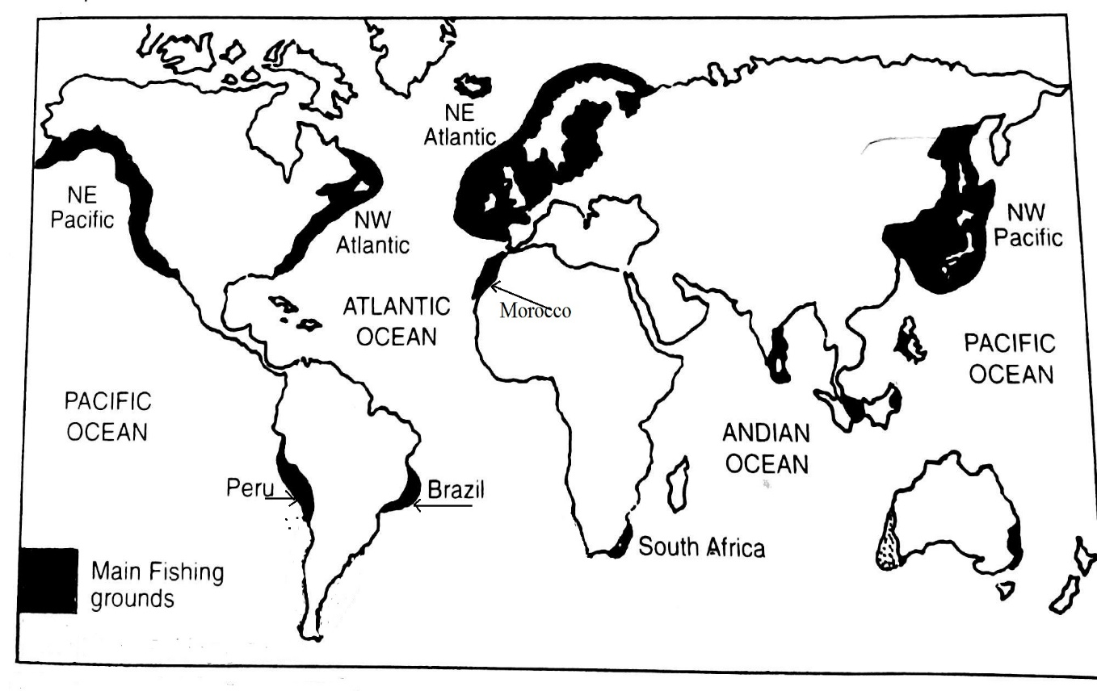
- Name and locate;
- One fishing ground in north Africa - Morocco (2marks)
- Nova, Scotia, New Brunswick, Quebec ( 2marks)
- – The meeting of Kamtchatka and Kuroshiwo ocean currents which leads to precipitation of minerals for the growth of planktons.
- Indented coastline provide calm waters, safe landing and sheltered fishing ports.
- The mountaineous nature of the area makes agriculture difficult hence people have engaged in fishing for their livelihood. Any two (4marks)
- – Countries have agreed to reduce the number of days when fishers can go to fish with large nets.
- Observing fish closed season to allow fish to breed
- i. Great distance from the ocean, Rain shadow effects of mountains, Effect of cold ocean current in area Any 1 (marks)
ii– industries release harmful gases which accumulate in the atmosphere contaminating natural state of air (2marks)
d. i.
- –Mulanje mountain (1mark)
- –Museums (1mark)
ii. –Increasing and improving accommodation facilities such as hotels.
- Improving roads and public transport to tourist places of interest.
- Advertisement within and outside Malawi to be improved.
- Putting mosquito nets or mosquito repellant in tourist places of interest to control malaria. Any two (4marks)
- a. i. – Ocean liner is designed for transporting people while cargo liner transports goods.
- Ocean liner has luxurious amenities while cargo liner has just large capacity for goods.
- Ocean liner operates on very fixed schedules while cargo liner operates on regular schedules. Any two (2marks)
- – Nature of items to be transported. Perishable goods need fastest transport while heavy and bulky goods require cheapest transport.
- The cost of transporting goods. People tend to be more economical when transporting goods hence they choose the cheapest.
- Distance. Longer distance require fastest but comfortable and safest transport to enhance relaxing and minimize damage. Any two (4marks)
b. Figure 4 shows locks operation. Use it to answer questions that follow;
- -In 1 the ship approaches D, the gate sluices are opened so that the water level between A and D beyond is the same. This enables ship to pass through D. In 2, D is now closed and A opened. As water level rises between A and D the ship rises with it. When the water level between D and A beyond is the same, the ship passes through A and sails. (3marks)
- – Water scarcity. – Technical failures. – Weight restrictions of ships. Any two (2marks)
- i. – It provides employment to people in recycling industries which helps to improve their living standards.
- It is source of revenue for the government through taxation.
- It can be a source of foreign earnings through export of recycled products
Any two (4marks)
- – Inadequate waste collection infrastructure
- Limited resources for waste management
- Inadequate education and training. Any two (2mark)
- 33.39% or 33.4% or 33% (2marks)
- – There will be strain on resources. –High levels of poverty
- Low quality of services. –Lack of peace and security. Any two (2marks)
- i. – Industrial regions like Kanengo require raw materials from surrounding rural areas.
- The high demand for charcoal as source of energy contributes to deforestation in the surrounding rural areas.
- The city’s expansion and growth puts pressure on the surrounding land leading to changes in land use patterns and environmental impacts. Any one (2marks)
- – Implementation of effective waste collection systems.
- Public awareness campaigns.
- Enacting and enforcing environmental regulations. Any two (2marks)

END OF MARKING KEY

